
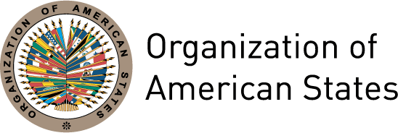

INTERNATIONAL DAY FOR THE ELIMINATION OF
VIOLENCE AGAINST WOMEN

MESSAGE FROM MINISTER MAUREEN CLARKE CLARKE,
PRESIDENT OF THE INTER-AMERICAN COMMISSION OF WOMEN

San José, Costa Rica
November 25th 2012

Today marks 21 years since the United Nations decided that November 25th would commemorate the sacrifice of the Mirabal sisters through the International Day for the Elimination of Violence against Women. Those of us that work for women’s right to live in a world free of violence also commemorate the voices of many other women that continue to suffer violence as a part of their daily lives.

The Belém do Pará Convention recognizes this reality and orients our fight to eradicate violence against women. For this reason, today we also recognize that this commemoration is part of a historic process that has involved almost all the governments of world, particularly in our region.

Today we also think of the advances that have been generated in women’s lives and in the democracies of the region by our participation in both public and private life. The example of the Mirabal sisters has been fundamental step in our region in terms of bringing women into public spaces, strengthening our democracies and bringing to light the importance of our presence in all spaces, as well as the validity of our human rights.

Nonetheless, the violence to which women and girls continue to be subjected in our region is alarming in its magnitude. Physical, psychological and sexual violence, trafficking in women and girls for labour and sexual exploitation, and abuse in schools, workplaces and health centres continue to be a daily reality for girls and women throughout the region. For this reason, our efforts must still be focused on eradicating violence, in building discourses that challenge those structural inequalities that underpin it, and in guaranteeing that the voices of so many other silenced women can finally be heard.

Today we do not forget the thousands of women and girls that are still victims of abuse and violence, who have been tortured, raped and murdered – they are victims not only of violence but of neglect and indifference.

The CIM is fighting to eradicate those laws that aggravate existing inequalities and to dismantle systems that allows for neglect and silence. We also work to make this violence visible and to build the channels necessary for the fulfillment of the commitments to eradicating violence against women adopted through Belém do Pará – guaranteeing a region free of violence for all. We call on this day for a re-doubling of efforts and the will to continue in this struggle.

